PMG201c.PE3 E-Commerce Website for Small Businesses
Given the context for the project as following, you are the PM for this project
A company is launching a multi-vendor e-commerce platform for small businesses. The
platform must provide:
- User registration for businesses to create their online stores.
- Payment integration with multiple payment providers.
- Product listing and order tracking features.
- Customer review system for feedback and ratings.
The website must support up to 10,000 vendors and 100,000 daily transactions.
Request 1 (weight 20%)
Identify 4 stakeholders and their relevant influences to the project. Define the strategy to manage each of those stakeholders.
Request 2 (weight 20%)
Identify at least 4 significant risks that you think the project faces. For each risk determine the evaluation (posibility, impact) and relevant mitigation strategies.
Request 3 (weight 35%)
Assume that you have defined and estimate schedule for one of main project deliverables with below high-level activities as following:
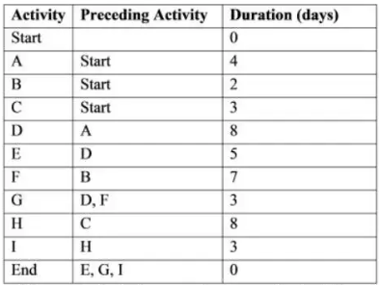
a. What are paths in the network diagram for the deliverable?
b. Identify the minimum duration to complete that deliverable?
c. What are activities which have the most flexibity (in term of time)?
d. In the 5th day, you are executing the activity D and found that you need to speed up the project schedule to recover 3-day delay. Define at least four solutions with relevant explanation and assumptions (if needed) to achieve that.
Request 4 (weight 25%)
The project team has completed a workload equivalent to $300,000 and has spent $400,000 to date. Assume that you were budgeted $500,000 for the work scheduled. At the start, the team has estimated project budget of $800,000 and the project need 6 months to finish. Evaluate the current project status and give forecasts to complete the project in terms of schedule and cost, show your calculations in details.

